Scope impact report 2023 to 2024


Advice, information and support. 4
Vision mission and values. 5
We provided disabled people with support and advice. 7
Aaron’s story. 8
Sharing experiences through the online community. 8
Ending the Disability Price Tag 12
Raising awareness of the devastating impact of the cost of living crisis. 12
Supporting people to manage extra costs. 12
Partnering with utilities companies to support disabled people. 15
We influenced change in the utilities sector. 15
Keisha’s story. 16
Managing extra costs. 16
Closing the Disability Employment Gap. 19
We supported disabled people to find suitable employment opportunities. 19
Working with businesses to remove barriers to inclusion. 21
We collaborated with employers to improve workplace policies, practice and culture. 21
Sarah’s story. 22
Sarah’s employment journey. 22
Supporting disabled families. 21

Lucy and Sam’s story. 24
Campaigning for inclusive playgrounds. 24
Transforming negative attitudes. 28
We called out negative rhetoric about disability benefits. 28
We empowered local people to create change in their communities. 28
We worked with the Department for Transport to create a new one-stop transport rights guide. 29
Putting equality, diversity and inclusion at the heart of everything we do. 29
Growing our membership to represent the diversity of the disabled community. 30
Building a movement of change 32
Thank you 34

Advice, information and support.

Vision mission and values

Our vision
We are Scope. We won’t stop until we achieve a society where all disabled people enjoy equality and fairness.

Our mission
We are determined to change the future. Together, as a collective movement of:
- disabled people
- campaigners
- donors
- volunteers
- communities
- and businesses
We work every day to challenge attitudes and end disability inequality.
An Equal Future is possible.

What makes us Scope

Pioneering
We are ambitious and determined to drive change. We focus on how we can make the most impact. We innovate and strive for better, pushing ourselves and our boundaries.

Courageous
We are single minded in our desire to achieve equality. We are bold, challenging the status quo, ourselves and each other. We are not afraid to fail fast and learn quickly.

Connected
We connect and collaborate internally and externally, to create a fairer society. We listen and share, tapping into the expertise of others.

Open
We are transparent about what we do and how we do things. Creating supportive, accessible environments – building trust with each other and our customers to achieve more.

Fair
We make sure everyone has a fair chance. We value and respect each other’s expertise and diversity. We take responsibility for what we do and support each other to succeed.

Advice, information and support.

We provided disabled people with support and advice.
- Our services, online advice and online community forum supported 4 million disabled people. That's almost 300,000 more people than the year before.
- Over 1.8 million people found support and information through our online advice and support pages.
- 78.6% of online customers told us that they found the information useful.
- Almost 2 million people visited our online community forum.
- 32,000 disabled people received information and advice through our helpline.
"Scope's online community is a new source of information and advice for me. Things that took me years to learn the hard way were confirmed in minutes! I wish I had known how Scope could help me sooner!”
“This website has given me valuable information to help me proceed with a claim for benefits that I did not know I was entitled to.

Aaron’s story.

Sharing experiences through the online community.

Aaron’s employment journey has been full of successes. But as a disabled person, he has faced significant barriers.
“When I was applying for jobs, I would ask whether they had disabled access. Often they would say, ‘We’ve got steps up to the main entrance, is that a problem?’ It really knocked my confidence.”
When Aaron found a role, he still encountered challenges.
“I had to do a fire evacuation drill. They got the evacuation chair out and said, ‘Here it is. Let us know if you need any help.’ And I said, ‘You know I can’t stand up?’ They assumed that I could transfer myself into another chair.”
Not being able to self-transfer during a fire evacuation led to Aaron working from home. Working from home reduced some physical barriers. But it isolated Aaron from the support and friendship of his colleagues in the office.
Aaron turned to Scope’s online community to connect with others who shared similar experiences.
“It was just nice to know that people were having the same experience as me. They were like, ‘Yes, it is a nightmare.’”
“It’s nice to be in an online community where there’s no awkwardness, it’s just anything you need.”
Being part of the online community motivated Aaron to tackle some of these barriers to employment. He decided to find a job that enabled him to support disabled people facing similar challenges. He now works at Scope.
“Joining Scope has made me so happy. It is so refreshing to feel like you’re not just a number on a spreadsheet.”

Ending the Disability Price Tag

Ending the Disability Price Tag

Raised awareness of the devastating impact of the cost of living crisis.
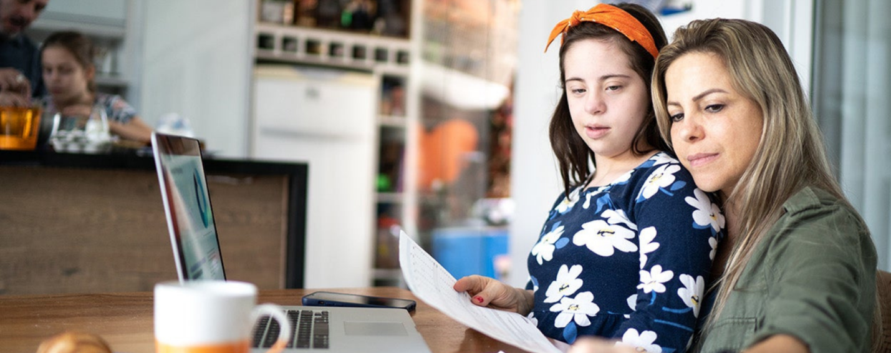
Our Cost of Breathing Crisis campaign showed how disabled people are being hit hardest by the cost of living crisis. Our TV advert featured 6 disabled actors. It was inspired by the real stories that our helpline colleagues hear from disabled people and their families every day. We wanted to let disabled people and their families know that Scope is here to help.
The campaign reached over 10 million people with the message that life costs more if you’re disabled. This campaign was made possible by support from ITV and Clear Channel, who donated TV advertising and outdoor media space.

We supported people to manage extra costs.
- This year, our Disability Energy Support with Water service identified an estimated £3.4 million in energy savings for disabled people. That’s £1.5 million more than the year before.
- The service gave vital information and advice to 8,883 customers.
- And we gave out £185,000 in emergency fuel and food vouchers.
"I’m a lone parent. I live with my 2 children, and one has additional needs. I have no support apart from benefits. I was struggling to afford food when I contacted Scope's helpline. The team helped me to access a food voucher, which helped me so much. I’m still finding it hard to manage the cost of gas and food, but I’m so thankful for the help. I truly appreciate it."
Helpline customer

We set out what needs to change.
Our 2023 Disability Price Tag research shows that disabled households face extra costs. This is on average £975 a month to have the same standard of living as a non-disabled household. Our Price Tag figure is often referenced in Parliament and in the media.
Our Life costs more report and Extra burden of essentials report show how disabled people have been affected by the cost of living crisis.
And give our recommendations to the government on supporting low-income disabled households. This includes the importance of introducing discounted energy bills. And fixing our broken benefits system.

We partnered with utilities companies to support disabled people.
Not all disabled households can simply reduce their energy usage and cut back on costs. We wanted to make sure that disabled people knew the options available to them. And to make sure that they were getting access to the support they are entitled to.
We ran our ‘Get winter ready’ digital marketing campaign. We reached over 1.5 million people with tips and advice and signposting to further support.

We influenced change in the utilities sector.
We continued to work with organisations in the utilities sector to create better outcomes for disabled people. We do this by helping them to better understand disabled customers’ needs and the barriers and extra costs they face.

Keisha’s story.

Managing extra costs.
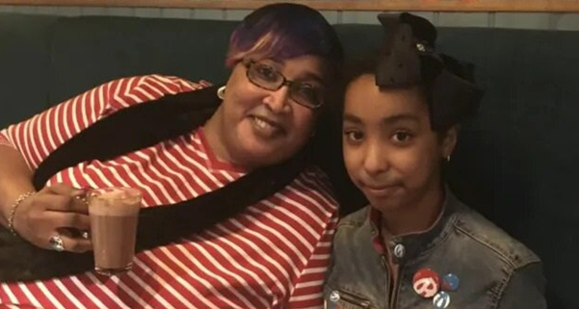
When Keisha had a major stroke, it completely changed her day-to-day life.
She now relies on electronic equipment, such as her wheelchair and oxygen machine.
This equipment helps her to be independent and do the things she loves, like cooking. But it also means she faces many new extra costs, including higher energy bills.
When the rising cost of living made it difficult for her to manage, Keisha contacted Scope’s Disability Energy Advice (DES) service.
“They didn't take long to reply, and the adviser helped me a lot. The service allowed me to get a £25 electric voucher, which was a lifesaver that week. That voucher helped me wash all my clothes.”
“She also advised me, for example, if you’re not using something, switch it off. Don’t fill the kettle with water that you’re using because it uses more energy.
“Scope doesn’t make you feel like you’re disabled. It makes you feel like somebody is there to help you."
Closing the Disability Employment Gap.

Closing the Disability Employment Gap.

We supported disabled people to find suitable employment opportunities.

- We supported 2,417 disabled people to develop their employment skills. We did this through education or volunteering.
- 461 people found a job that they wanted.
- 152 of these people continued to receive support when they started their new jobs, helping them to settle in.
- ‘We also supported 332 disabled people in Wales into work, education or volunteering. We did this through our partners:
  - Legacy in the community
  - Whitehead Ross
  - Resource Wales
  - Disability Can Do
- 242 disabled people found a job through our eLearning platform, Learn at Scope.
- 5,003 vacancies were added to our jobs board, which received 28,693 hits.
“One of my concerns was finding an employer who would be happy to offer me flexibility as a disabled person. My Support to Work adviser was very prompt in sending me examples of jobs like this. This improved my confidence and enabled me to use a job board which resulted in a job offer!”
Support to Work customer
“Support to work helped me leave a toxic work situation and find a more suitable job. My adviser is now helping me get through my probationary period and my new job. This support is huge during this time as change is always tricky for me.”
Support to Work customer

We worked with businesses to remove barriers to inclusion.
Our utilities innovation challenge event brought together industry experts and disabled people. Together we identified some of the challenges disabled people face. And worked together to find solutions. The event was sponsored by Salesforce, Experian and Charis Grants.
“[The event helped us to look] at what we can do in the workplace to support our disabled colleagues and make sure we are including disabled people in all decision making.”
Event attendee

We collaborated with employers to improve workplace policies, practice and culture.
We trained 32 companies to be more inclusive. Almost 60,000 users accessed the disability inclusion resources on the Scope for Business website.
Our Workplace Retention report explored the reasons that disabled people are more likely to leave their jobs.
It offered our recommendations on how the government and employers can better support disabled employees. 90 employers, policy makers and MPs joined with us at an event to discuss the findings.

Sarah’s story.

Sarah’s employment journey.
Sarah works as the Chief Scientific Officer for a start-up company. She likes her job, but she faced many challenges on her journey to employment. She faced long delays in getting Disabled Students’ Allowance, so she did not have the equipment needed to finish her PhD.
When she applied for jobs, Sarah also faced barriers during the recruitment process.
“Employers expected me to travel a very long way for an interview which you could easily do online. They wanted me to be in the office a lot with no reason that I could quite understand.”.”
Sarah accessed our Support to Work service for support during her job search. Sarah’s advisor provided support through phone calls and virtual meetings. This helped Sarah manage the stress of job applications and interviews.
“The one thing I probably found most helpful was just having someone to chat to. My advisor would support me and just chat through things. She gave me the confidence to make the decisions for myself.”
Sarah now works for an employer who gives her the flexibility and support she needs to do her job well. They make sure she has the equipment she needs. And have created an inclusive work environment.
“They know that if I work in the ways that I find most helpful, and they provide the support, then it’s best for everyone. Now I just turn up to work as myself. I’m not hiding anything about me. It makes me more likely to stay in the role because I am happy and comfortable. And I will be doing my best work too, because I feel valued.”

Supporting disabled families.
Information and advice.
- 1,556 families had tailored advice, information and emotional support from our family services team.
- 164 disabled children were supported to take part in activities such as Brownies, drama groups and after school clubs.
- 129 activity providers had support to make their activities more inclusive for disabled children.

Campaigning for inclusive and accessible playgrounds.
Our Let’s Play Fair campaign called for local authorities to work with disabled families to create inclusive playgrounds. So that every disabled child can play. Scope campaigners assessed 1,004 local playgrounds to create the Playground Accessibility map. The interactive map helps parents and carers to see whether a playground might be accessible and inclusive for their child. In July 2023, the Government started a consultation on guidance for inclusive playgrounds. A campaign win for Scope and our campaigners!

Lucy and Sam’s story.

Campaigning for inclusive playgrounds.
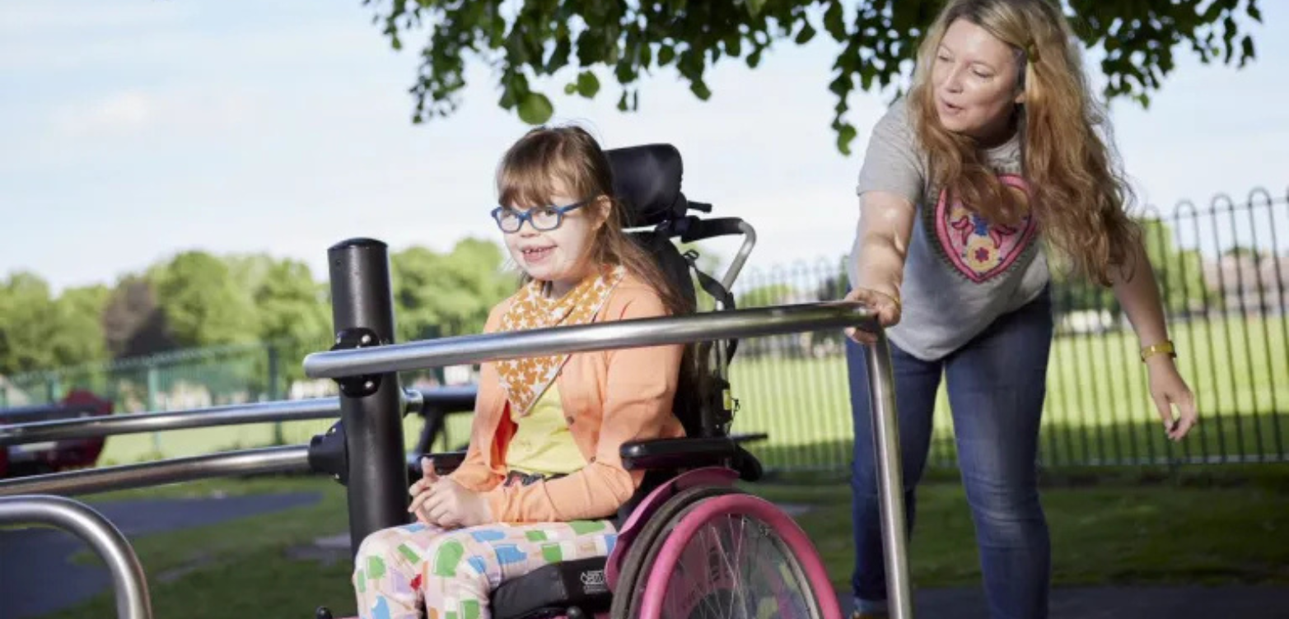
Inaccessible playgrounds make it really challenging for wheelchair users like Lucy to play. Lucy was born with a very rare, almost unique condition called an unbalanced translocation. Lucy is a wheelchair user and non-verbal. But the barriers Lucy faces are not just physical. Lucy’s mum Sam says,
“As Lucy is getting older, I’ve really noticed the impact on her emotions. You can tell she knows when there’s nothing for her at a playground. And it’s crushing, it’s really crushing. Young children stare, I understand that, that’s fine, but the parents do too. And I would like to change that. Lucy has just as much right to be in a play area as any other child.”
Sam is a successful and passionate campaigner for inclusive and accessible playgrounds. She uses her personal and professional experience to advocate for better planning and design. She has done this at the highest levels of Government. Sam generously brought her experience as a parent campaigner to support our Let’s Play Fair campaign.
Sam found the needs of disabled children are often overlooked when playgrounds are designed. She had to advocate for proper consultation with parents of disabled children. Sam's efforts led to the installation of inclusive play equipment at her local park. This included wheelchair-accessible play equipment and accessible swings.
“The difference when we go to an accessible playground is huge. Lucy can hear other kids squealing with fun and Lucy is being included.”
Sam’s amazing efforts have inspired others to get involved too. Scope’s Playground Accessibility Map and Inclusive Playground Guide can support you to make inclusive playgrounds happen in your community.
We hope more people will continue to use these tools to campaign for inclusive playgrounds in their communities.
Closing the Disability Employment Gap.

Transforming negative attitudes.

We called out negative rhetoric about disability benefits.
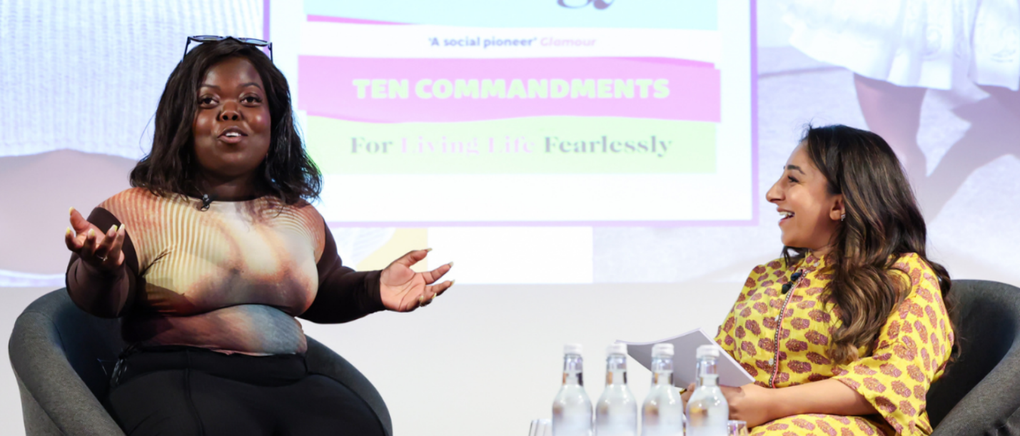
The previous Government’s autumn statement included rhetoric that demonised disabled people who are unable to work. We responded quickly. We held the government to account for promoting negative attitudes towards disabled people. Scope’s statement was featured in almost every national newspaper. And interviews with Scope spokespeople and storytellers featured across all major broadcasters.

We empowered local people to create change in their communities.
Our Youth Community Collective and Community Engagement members delivered 95 projects. Over 5,000 disabled people took part across the UK. These projects were designed to improve the lives of local disabled people and to create change in their communities. Projects included a series of events in Cardiff to mark Disability Pride Month. The events included a mass cycle ride and an art exhibition at Cardiff central library. The exhibition featured art and creative writing exploring the question ‘What does Disability Pride mean to you?’.

We worked with the Department for Transport to create a new one-stop transport rights guide.
The Right to Ride guide helps disabled people to know their rights. And to be empowered to act when things go wrong. 4 years ago, we called for this guidance to be made available. And we worked with Government to create it. A win for Scope campaigners!

Putting equality, diversity and inclusion at the heart of everything we do.

In January 2023, we launched our 3 year Equality, Diversity and Inclusion (EDI) strategy. Our colleagues, members, and Scope volunteers shared their experiences to help us create this strategy. It outlines our ambitions and details how we will take action to build a culture that is accessible and inclusive.
We made a number of changes to our internal processes, including:
- We have removed barriers to employment at Scope. This includes improving the accessibility of our job adverts, our website, and our application forms. And we now share interview topics with candidates in advance.
- We made disability equality training mandatory for all new colleagues.
- We continued regular EDI roundtables for colleagues. These offer a safe space to explore various topics, including faith inclusion, sexism, social class, and LGBTQ+ inclusion.
- We renewed our status as a Level 3 Disability Confident employer. This is the highest level of the Government’s Disability Confident scheme.

We explored how reframing disability in media campaigns can improve attitudes.
Our pioneering What works research involved an experiment with over 5,000 participants, looking at the impact of different messages. We found that only 1 in 10 respondents had seen a disabled person who was Black, Asian or minority ethnic on TV in the last 12 months. We worked with Paralympics GB to share our findings and recommendations. And we worked with high profile supporters Shani Dhanda and Fats Timbo to share their experiences with ITV News. Almost 250 people attended or joined the livestreamed event. Our findings were also referenced in a Parliamentary debate.

We grew our membership to represent the diversity of the disabled community.
We increased the diversity of our membership, with 24.9% of Scope members identifying as Black, Asian, or minority ethnic, up from 17.8% in May 2023. Our members attended events including ‘Celebrating Black History Month Together’ and ‘Disability and the South Asian Community.

Building a movement of change

Building a movement of change.
We know we cannot achieve our vision and goals alone. We are part of a larger, diverse movement that is seeking to end injustice for the 16 million disabled people in the UK. We want to provide a platform to disabled people and amplify their voices, as well as mobilise wider society in support of justice and equality.
Together we have achieved some incredible things:
- 71,000 Scope campaigners took over 29,000 actions. They signed petitions, emailed local MPs, and shared information with others. 17, 000 new members joined us this year.
- 2,300 Scope members helped to shape our strategy and our work.
- 2,500 research panel members expressed their views and experiences. Contributing to reports and research on a range of topics. And guiding the development of projects.

Thank you

Thank you.
We cannot achieve an equal future without our:
- colleagues
- partners
- trustees
- supporters
- donors
- volunteers
Thank you for being part of this diverse movement.

Celebrity ambassadors
- Sophie Morgan
- Shani Dhanda
- Alex Brooker
- Nicolas Hamilton
- Samantha Renke
- Lee Ridley
- Ben Elton
- Richard Herring

Charity ambassadors
- Neil Blackley
- Peter Brewer
- Isabel Hudson
- James Melville Ross
- Mark D Smith

Corporate partners
- Amazon
- Barclays
- Bupa
- Clear Channel
- Deloitte
- Howden Holdings
- HSBC
- M&S
- NBC Universal
- Sainsbury’s
- Tesco
- Trainline

Organisations supported by Scope training
The following organisations have used Scope’s expertise on disability inclusion. Scope’s support has included content accessibility, digital accessibility audits, disability inclusion training, and access to Scope's research panel of disabled consumers.
- Academy of medical sciences
- Accurx
- Angela Martin
- Art Fund
- Barbican
- Barratt
- British Heart Foundation
- Creative Equals
- Department for Business and Trade
- Energy UK
- Essex County Council
- Evan Evans
- Fundraising Everywhere Ltd
- FutureNet
- Gettinge
- Gillibrand
- Hill & Knowlton Strategies
- Hockerhill College
- Houses of Parliament
- JD Williams
- John Lewis
- Joseph Rowntree Foundation
- Jury’s Inn
- Liverpool School of Tropical Medicine
- London School of Economics and Political Science
- Man Group Operations Limited
- Motionspot
- National Physical Laboratory
- National Energy Action
- NHS North East London
- NHS North West London
- NHS Sussex
- Nouvana
- OC and C Strategy
- Oxford Languages
- Pharmacy2U
- Pinsents Masons
- Pladis
- PPGF Sunswap
- SCRAP Car
- Skanska
- Skipton Building Society
- Spectrum Life
- Step Change Debt Charity
- Three Hands
- Toronto Dominion
- Toyota
- Virgin Money

Scope utilities members
We work with our Scope Utilities Members with the aim to reduce costs and improve utility services for disabled people. And tackle the everyday issues they face paying for bills.
- Anglian water
- BU UK Ltd
- EDF Energy
- Eon Next
- Outfox the Market
- OVO Energy
- SGN
- Shell
- South East Water
- UK Power Networks
- Wales and West Utilities

Trusts and foundations
Scope is grateful for the support of over 70 trusts and foundations including:
- People's Postcode Lottery
- British Gas Energy Trust (BGET)
- Energy Savings Trust (EST)
- The National Lottery Community Fund
- The Zochonis Charitable Trust
- The TK Maxx and Homesense Foundation
- The Liz and Terry Bramall Foundation
- Houghton Dunn Charitable Trust

